**Project Summary**

Problem 2:

Submit your saved microstrategy file named "<Student Name> - Restaurant Location Analysis.mstr " containing your project dashboard with both the sheets and all the visualizations as required in the exercise.

Ans:

The following dashboard analyzes the performance of the fast-food restaurant Blazin’ Burger located at 3 different locations in New York namely B.B Upper West Side, B.B. Lower Manhattan and B.B. Brooklyn . The various visulaizations in this dash board are as follows:

**Visualization 1(Revenue Trends):**

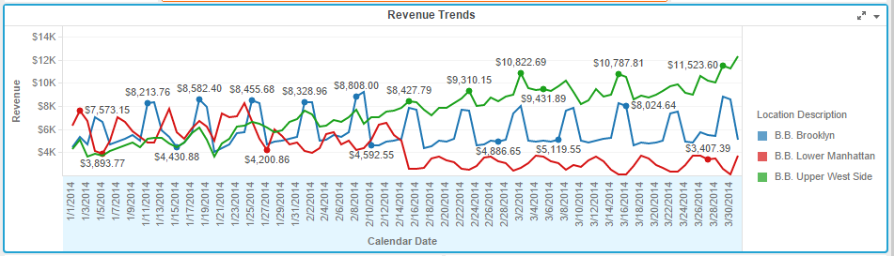

From the above revenue trends figure we can observe that the revenue for all three locations were similar till middle of February. But later on the revenue started increasing in the B.B Upper West Side region, remained same in the B.B. Brooklyn region, and started decreasing in the B. B. Lower Manhattan region. This was the changes that could be observed in the revenue trends of these 3 regions.

**Visualization 2(Avg. Revenue vs Order Count By Day of Week):**

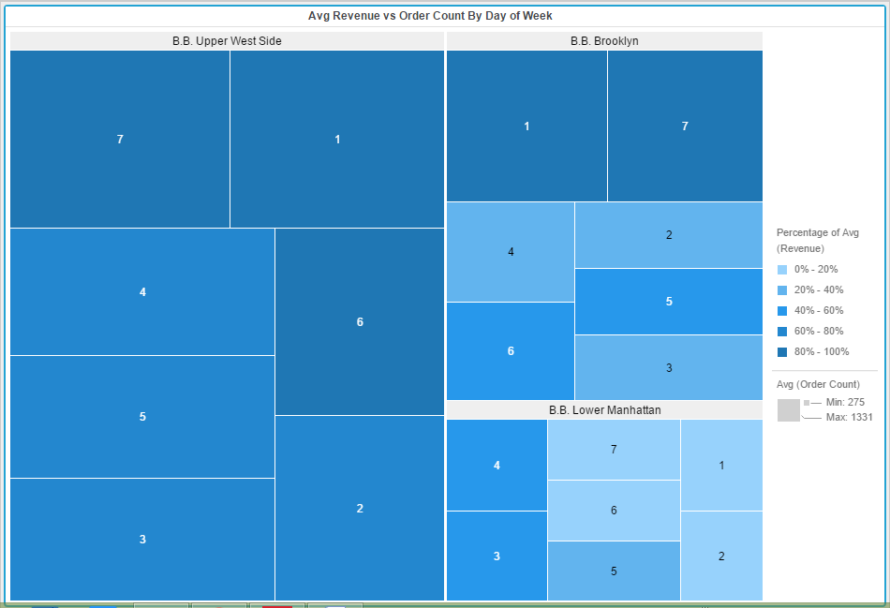

The new heat map shows the avg. revenue vs order count on specific days of a week . The different shades of the blue color denotes the varying percentage seta of the average revenue.

By observing it is clear that the B.B. Upper West Side region has a good average revenue while B.B.Brooklyn and B.B. Lower Manhattan regions have average revenues on Saturdays ,Sundays and Tuesdays, Wednesdays respectively.

**Visualization 3(Order and Item Count Correlation):** 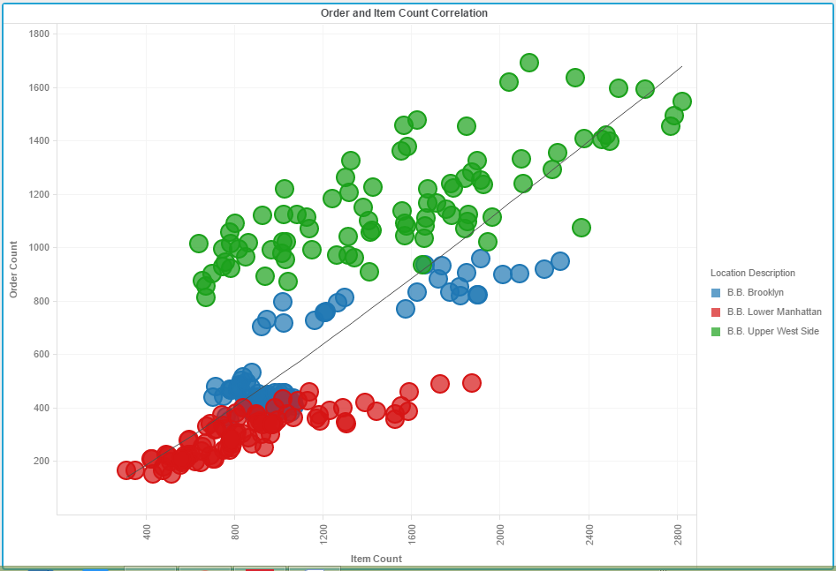

The above visualization shows the order count vs Item count correlation for all the three regions and for each week day.

**Visualization 4(Average Scores by Zip Code):**

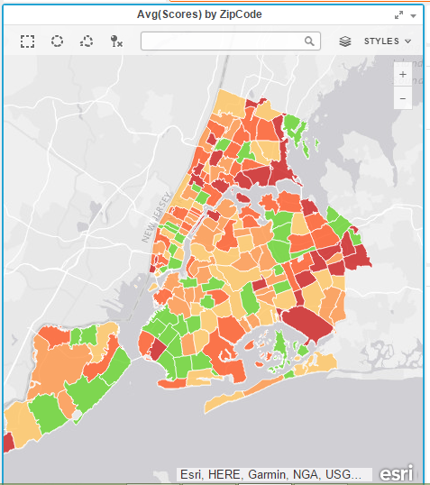

The map shows the zip codes of New York colored by the average health inspection score of the restaurants in that area. The lower the score, the better the grade. The lower numbers are green and higher numbers are red.

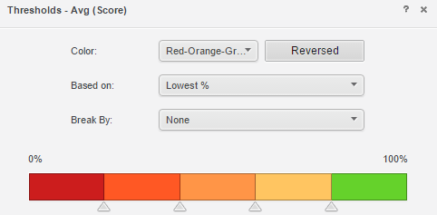

The threshold indicates that the highest scored regions are green (have lowest grade) in color whereas the lowest scored regions are red (have highest grade) in color.

**Visualization 5(Revenue Performance vs Avg. Heath Score):**

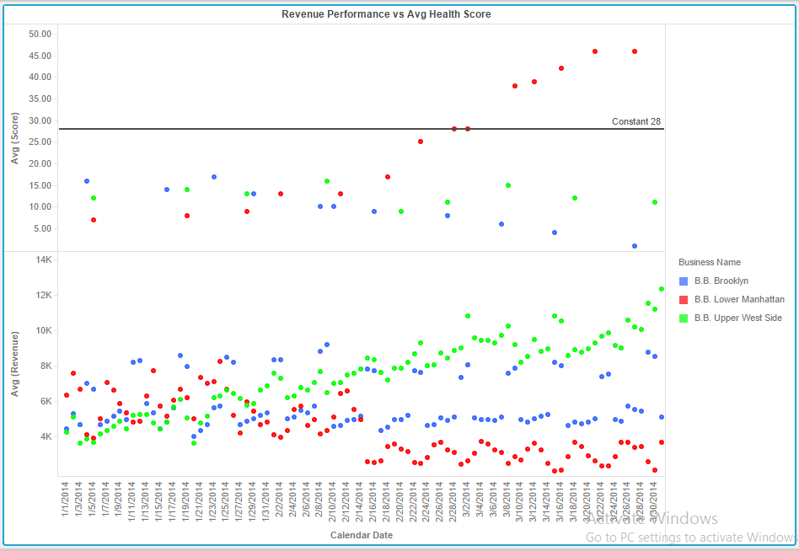

The graph shows how health inspection results (score) affected the revenue performance of each restaurant location. Any health inspection score above the reference line receives a C grade. From the figure it is clear that the health inspection score heavily impacts revenue performance for the restaurant location. Several conclusions that can be drawn from this figure are:

The health inspection score for the B. B. Lower Manhattan region is gradually increasing (indicates a lowest grade) from the middle of February. So the revenue performance for that region is gradually decreasing from the middle of February.

The heath inspection score for the B. B. Upper West Region is less( indicates a highest grade). So the performance of that region is gradually decreasing.

**Visualization 6(Average Scores by Boro):**

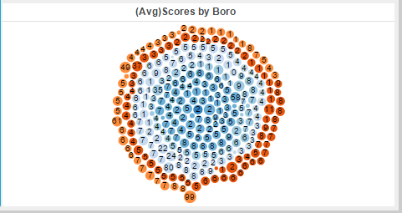

The bubble chart show scores based on Cuisine Type and by Boro. We can identify that the cuisine type code 27 has good fare across multiple boro’s .

**Conclusion:**

Thus by analyzing the above 6 visualizations of the Blazer Burger restaurant present at 3 locations in The New York City , the overall performance was significantly poor because of the factors such as the food types that are not available in the locations on the respective days, inspection scores .